Crypto Payment Gateway

**Haider Yaqoob**

**Aamir Mushtaq**



Department of Computer Science

COMSATS UNIVERSITY ISLAMABAD,

ATTOCK CAMPUS – PAKISTAN

SESSION 2016-2020

Crypto Payment Gateway

*Undertaken By:*

**HAIDER YAQOOB**

CIIT/SP17-BCS-012/ATK

**AAMIR MUSHTAQ**

CIIT/SP17-BCS-001/ATK

*Supervised By:*

**Dr. Chaudary Shahzad Faisal**

**Dr. Khalid Mehmood**

A DISSERTATION SUBMITTED AS A PARTIAL FULFILLMENT OF THE REQUIREMENTS FOR THE DEGREE OF BACHELOR OF SCIENCE IN COMPUTER SCIENCE

DEPARTMENT OF COMPUTER SCIENCES

COMSATS UNIVERSITY ISLAMABAD,

ATTOCK CAMPUS – PAKISTAN

SESSION 2016-2020

UNDERTAKEN

We certify that this is my/our own work. The work has not, in whole or in part, been presented elsewhere for assessment. Where material has been used from other sources it has been properly acknowledged. If this statement is untrue, we acknowledge that we will have committed an assessment offence and shall be liable to punishable action under the plagiarism rules of HEC.

______________ ____________________

Haider Yaqoob Aamir Mushtaq

SP17-BCS-012 SP17-BCS-001

Dated: 5-12-2020 Dated: 5-12-2020

**FINAL APPROVAL**

Certified that we have read this project report submitted by Mr. Haider Yaqoob and Mr. Aamir Mushtaq and it is, in our judgment, of sufficient standard to warrant its acceptance by Department of Computer Science, COMSATS University Islamabad, Attock Campus, for the BSCS degree.

***Committee:***

External Examiner Unknown

Supervisor Dr. ChaudaryShahzad Faisal

Professor

Head of the department Dr. Khalid Mehmood

**DEDICATION**

*To my Loving Parents and Teachers who helped me in every phase of my life and trusted me no matter what.*

**ACKNOWLEDGEMENT**

I must thank my parents, whose love and guidance are with me in whatever I pursue. They are the ultimate role models. I am grateful to all of those with whom I have had the pleasure to work during this and other related projects. My teachers and mentors have provided me extensive personal and professional guidance and taught me a great deal about this project and software engineering in general.

**PROJECT BRIEF**

PROJECT NAME CRYPTO PAYMENT GATEWAY

ORGANIZATION NAME COMSATS UNIVERSITY ISLAMABAD, ATTOCK CAMPUS

OBJECTIVE PAYMENTS USING CRYPTOCURRENCY

UNDERTAKEN BY HAIDER YAQOOB & AAMIR MUSHTAQ

SUPERVISED BY Dr. CHAUDARY SHAHZAD FAISAL

PROFESSOR

Dr. KHALID MEHMOOD

HEAD OF DEPARTMENT

COMPUTER SCIENCE

CUI, ATK

STARTED ON 01-09-2019

COMPLETED ON 03-12-2020

COMPUTER USED HP FOLIO AND LENOVO

SOURCE LANGUAGE HTML, CSS, JAVASCRIPT, NODE.JS, VUE.JS

OPERATING SYSTEM WINDOWS AND LINUX

TOOLS USED VS CODE, Docker, Apache Kafka, FIGMA

**ABSTRACT**

Our project Crypto Payment Gateway is an automated payment processing system for the bitcoin currency.  It is an online transaction platform which allows different merchants and businesses to accept payments in Bitcoins just as easily they accept payments from credit cards, debit cards, or Paypal. The system will be blockchain based which will ensure that one entity will not be able to control or manipulate the system. Our bitcoin payment gateway offers several benefits, such as fast transaction speeds, low costs, and the elimination of the need for a third-party intermediary to process transactions.

**TABLE OF CONTENTS**

Table of Contents

Chapter 1 1

Introduction 1

1 Introduction 2

1.1 Brief 2

1.2 Relevance to course modules 3

1.3 Project Background 3

1.4 Literature Review 3

1.5 Analysis from Literature Review 4

1.6 Methodology & Software Lifecycle 4

1.6.1 Rationale behind selecting this Methodology 4

Chapter 2 6

2. Problem Definition 7

2.1 Problem Statement 7

2.2 Deliverable and Development Requirements 7

2.3 Current System 8

Chapter 3 10

Requirement Analysis 10

3 Requirement Analysis 11

3.1 Use Case Diagrams 11

3.2 Detailed Use Case 16

Chapter 4 20

Design and Architecture 20

4 Design And Architechure 21

4.1 System Architechure 21

4.2 Data Representation 22

4.3 Process Flow/Representation 23

4.3.1 Payment Processing 23

4.3.2 Update Password 24

4.3.3 Forget Password 25

4.3.4 Withdraw Amount 27

4.3.5 Download Plugin 28

4.3.6 Request ApiKey 28

4.4 Design Model 30

Chapter 5 32

Implementation 32

5 Implementation 33

5.1 Algorithm 33

5.1.1 Elliptic Curve Digital Signature Algorithm or ECDSA 33

5.1.2 Cryptographic Hash Functions 33

5.2 External APIs 34

5.2.1 Bitcore 34

5.2.2 BitcoinD 34

5.2.3 Apache Kafka 34

5.3 User Interface 34

5.3.1 Screen Images: 34

Forget Password Page 38

Dashboard Page 39

Settings Page 39

5.3.2 Screen Objects and Actions: 40

Chapter 6 41

Testing and Evaluation 41

6 Testing and Evaluation 42

6.1 ManulaTesting 42

6.1.1 System Testing 42

6.1.2 Unit Testing 43

6.1.3 Functional Testing 43

6.1.4 Integration Testing 44

6.2 Automated Testing 45

Tools used: 46

7 Conclusion and Future Work 48

7.1 Conclusion 48

7.2 Future Work 48

**List of Figures**

3.1.1 Merchant Sign Up/ Log In Use Case 11

3.1.2 Merchant Dashboard 12

3.1.3 Merchant Withdraw 13

3.1.4 Merchant Settings 14

3.1.5 Buyer/Client Use Case 15

3.1.6 Buyer Payment Use Case 15

4.1.1 System Architecture 21

4.2.1 Data Representation 22

4.3.1 Process Flow 23

4.3.2 Process Flow 24

4.3.3 Process Flow 26

4.3.4 Process Flow 27

4.3.5 Process Flow 28

4.3.6 Process Flow 2

4.4.1 Design Model 30

4.4.2 Design Model 31

4.4.3 Design Model 31

Y

5.3.1 Landing Page 37

5.3.2 SIgn Up Page 37

5.3.3 Login Page 38

5.3.4 Landing Page 38

5.3.5 Dashboard Page 39

5.3.6 Settings Page 40

**List of Tabl**

Table 3.2.1 SignUp/LogIn 16

Table 3.2.2 Merchant Dashboard 16

Table 3.2.3 Withdraw Amount 16

Table 3.2.4 Merchant Settings 17

Table 3.2.5 Buyer proceed payment 17

Table 3.2.6 Buyer send amount 17

Y

Table 6.1.1 System Testing 43

Table 6.1.2 Functional Testing 44

Table 6.1.3 Integration Testing 45

Table 6.1.4 Automated Testing 46

Chapter 1

Introduction

# Introduction

[Cryptocurrency is a digital form of currency](https://blockgeeks.com/guides/what-is-cryptocurrency/), a medium of the electronic exchange, to make safe transaction, it uses cryptography algorithm. The technology runs on blockchain technology that acts as a tool for implementation of cryptocurrency. In short, this prevents double spending and removes the need for centralized payment processors to verify funds and record transactions. Crypto payments offer great transparency and immutability.

**Processing cryptocurrency payments through the payment gatewa**y:

The proposed system will help in making a transaction in a very secure way because it's the merchant who will be in control of their funds without any third party involvement. When customer's pay in cryptocurrency, the payment will be directly transferred to the merchant without sharing the customer's information. The system will be blockchain based which will ensure that one entity will not be able to control or manipulate the system. When a buyer comes to merchant website and wants to pay in bitcoin we will show him an address. Buyer will send amount in the provided address. For each new visitor, we will generate different address for payment. Merchant has an account on our website on which we provide the merchant with the information of his balances, payments he received and the withdrawals he make.

## Brief

The crypto payment gateways give the merchants the facility to make and accept payments in cryptocurrencies like bitcoins. With the help of [blockchain technology](https://espeoblockchain.com/blog/best-blockchain-platform/) it simply makes the whole process super convenient and less costly to use. A crypto currency payment gateway is the same as any other payment gateways that we would use with your business, the only difference here is that the traditional payment platforms, such as Payoneer, PayPal or worldpay accept fiat currencies and cryptocurrency payment gateways accept cryptocurrencies such as bitcoins and etherium.

## Relevance to course modules

This project is relevant to the courses, Programming fundamentals, OOP, Web technologies, Data bases, Software engineering 1, Human Computer Interaction, RWS (Helping for documentation), all these courses we have studied during BCS. Project involves programming & logics, which we learn during our degree. We are also using html, css, JavaScript, vue.js and node.js to make this project.

## Project Background

Since the number of users of these virtual currencies is increasing every day, many countries are in the process of drafting a regulatory framework for the use of cryptocurrencies. There are many advantages of using Bitcoin as a payment option. Cryptocurrency payment gateways are borderless payment networks that allow smooth transfer of cryptocurrencies and enables users and merchants to do transactions in bitcoins. There is no third-party between a merchant and a customer (user). Merchant is always in full control of the funds. There is no subscription or processing fees by using crypto payment processors.

## Literature Review

The existing payment processing gateways allows communication between customers and payment processors use various security tools to secure a customer’s payment information; however, the security provided by a payment gateway cannot completely protect and secure a customer’s confidential payment information when a merchant also has the ability to obtain the payment information in some form. Also, not all merchants provide a secure payment environment to their customers and they also hide their payment policies. Consequently, this exposes a customer’s payment information to risks of being compromised or misused by merchants or stolen by spammers and hackers. Transaction speed and confirmation is also an issue in existing crypto payment gateways so the slower transaction confirmation results in the merchant taking a longer time to receive payment and process his product purchase.

## Analysis from Literature Review

The concept of our project may be developed in Industry, but not yet created at FYP level. We are adding some new features like

* Direct peer-to-peer Bitcoin payments.
* Fast transaction and security.
* No transaction fees.
* No processing fees.
* No middleman.
* Enhanced privacy.
* Enhanced security.

There is no third-party between a merchant and a customer. Merchant is always in full control of his funds. There are no processing or subscription fees.

## Methodology & Software Lifecycle

Software methodology and process methodology for proposed system is discussed below:

* **Software Methodology:**

We will use Microservices method to develop our system. Reason behind selecting this method is because it’s easy to develop a system when it’s broken into smaller pieces which can then work together. Each part of system can be developed separately.

* **Process Methodology:**

We will use Iterative and Incremental process model for our system, Main reason is that it breaks the system functionality into increments. We can evaluate system according to requirements after each iteration.

### Rationale behind selecting this Methodology

The reason behind selecting this methodology and SDLC are as follows:

* We select this methodology because we need to breaking up our development plan into smaller, working pieces. Those pieces are then developed, implemented, and tested piece by piece. This ensures that we can easily use feedback to make changes early and often.
* This frequent testing allow us to be more flexible when new circumstances arise rather than an unexpected change throwing off the entire project.
* With every Iteration, we make progress that refines the software until it meets its goals.
* Through this the development is fast and features are added in a systematic way and we are also expecting major edits during the development cycle.

Chapter 2

Problem Definition

# Problem Definition

In this Chapter we will discuss about the problem statement in current system and relate them to the solution provided by our project. There are many online payment problems that existing crypto payment processor tend to face. Some of these issues may include but are not limited to.

# Problem Statement

Most of us are familiar with digital payments. However, there are unique challenges when implementing them for cryptocurrencies and blockchain technologies.

* **Transaction Speed & Confirmation:** The slower transaction confirmation results in the merchant taking a longer time to receive payment and process his product purchase. This creates a hassle for both client and the merchant.
* **Transaction Cost:** The blockchain network is congested and the client has to wait 10–15 minutes for the transaction to be confirmed. The client is also unwilling to pay a higher transaction fee for his purchase to be confirmed. Likewise, the merchant is only willing to accept his payment only after his transaction is confirmed.
* **Chargeback:** A chargeback is an even bigger problem than transaction cost. A customer charges back the money to demand a refund after making a purchase and that is also a kind of fraud. These chargebacks can have a negative impact on the store’s rating.
* **Hidden fee structure:** Payment gateways and processors have long played the hidden fee game for their users. Some gateways make it as difficult as possible to know how much markup you’re paying by using strange terms and conditions that would baffle even the most experienced business owner or retailer. Just a few examples include early termination fees, monthly minimum fees, statement fees, and batch fees.

# Deliverable and Development Requirements

Requirements are important part of software development. Before starting a project, requirements are gathered, to formulate and manage the designing phase.

* + 1. **Deliverable Requirements:**
* **Web based application:** A web based application will allow merchants and their clients to use the bitcoin payment gateway, Merchants will integrate the payment gateway into their ecommerce stores and then use it as a payment processor.
* **Integration plugin:** We will also provide the integration plugin to the merchants and other businessman, so that they can integrate the bitcoin payment gateway to their websites or other ecommerce stores and get benefit from the payment processor.
* **Project Report:** A complete Project Report that includes Software Requirements Specification, Software Design Specification, GUI Mockups, Test Cases, and other major tasks that we have performed.
  + 1. **Development Requirements:**

Following are the requirements which the user of the system must fulfill in order to run the system on their laptops or PCs.

* **OS Requirements:** Windows 7, Windows XP, Windows 8, Windows 8.1, Windows 10.
* **DBMS Requirements**: Maria db, Php, Connectivity of the application with the server using integration plugin.
* **Other Requirements:** For Mockups and presentation we use MS Word, MS Power Point.

# Current System

Already implemented crypto payment gateways are also working efficiently but merchants needs to pay for these payment gateways for their online shops and businesses, some of the crypto payment gateways have issues, like

* Transaction Speed & Confirmation
* Transaction Cost
* Security
* Blockchain Specific Issues

We firmly believe that in order for crypto-currencies to become more than merely a speculative asset, it needs to be used by more users and merchants, and thus the above challenges have to be tackled. When our own crypto payment gateway will implemented then we will use it with any ecommerce stores like shopify and WordPress etc and also sell it to other merchants.

Chapter 3

Requirement Analysis

# Requirement Analysis

## Use Case Diagrams

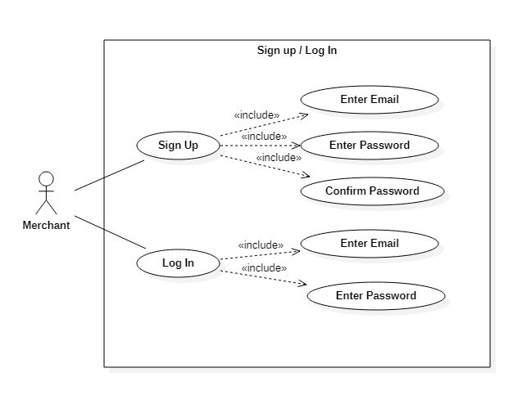

**Figure 3.1.4 Merchant Sign Up/ Log In Use Case**

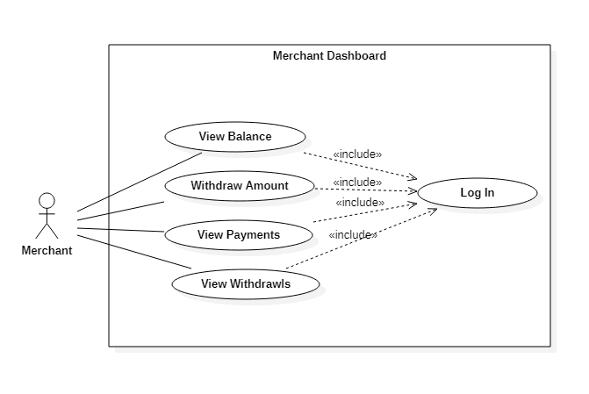

**Figure 3.1.4 Merchant Dashboard**

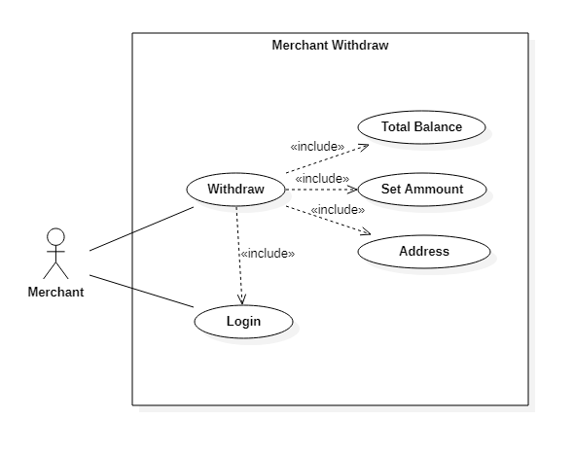

**Figure 3.1.4 Merchant Withdraw**

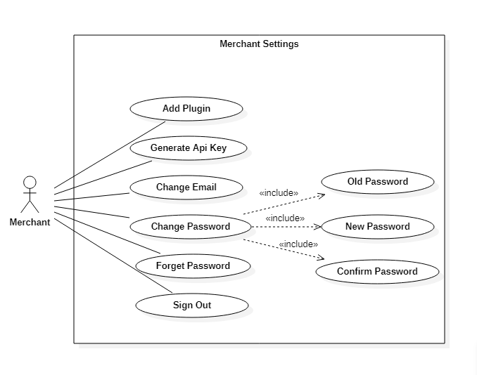

**Figure 3.1.4 Merchant Settings**

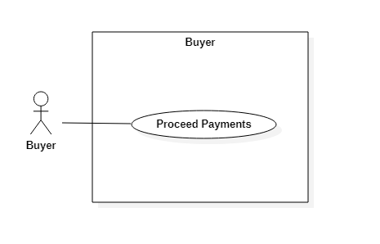

**Figure 3.1.4 Buyer/Client Use Case**

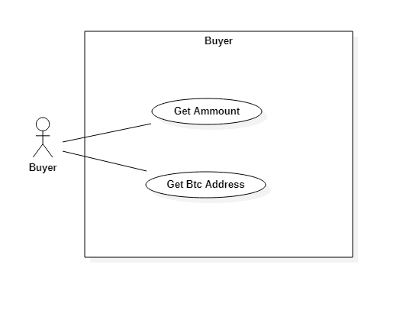

**Figure 3.1.4 Buyer Payment Use Case**

## Detailed Use Case

|  |  |
| --- | --- |
| **Use Case Name** | **Sign Up / Login** |
| **Description** | Merchant SignUp/LogIn to system n order to access the functionality of system. |
| **Actor** | Merchant |
| **Pre-Condition** | System must be connected to Internet, Merchant just see the landing page. |
| **Post-Condition** | Merchant successfully login to the system, Now merchant have access to the dashboard. |

**Table 3.2.1 SignUp/LogIn**

|  |  |
| --- | --- |
| **Use Case Name** | **Sign Up / Login** |
| **Description** | Dashboard shows all the functionalities including view balance, withdraw amount, view received payments and view withdrawals. |
| **Actor** | Merchant |
| **Pre-Condition** | Merchant must need to sigup and login to access dashboard. |
| **Post-Condition** | Merchant can perform the required activities. |

**Table 3.2.2 Merchant Dashboard**

|  |  |
| --- | --- |
| **Use Case Name** | **Withdraw Amount** |
| **Description** | Merchant can withdraw the amount from the payment gateway. |
| **Actor** | Merchant |
| **Pre-Condition** | Merchant gives the required amount and the address of his wallet. |
| **Post-Condition** | The required amount is successfully sent to that address of his wallet. |

**Table 3.2.3 Withdraw Amount**

|  |  |
| --- | --- |
| **Use Case Name** | **Merchant Settings** |
| **Description** | Merchant can change the settings, integrate the plugin for woocommerce and generate the Api Key. |
| **Actor** | Merchant |
| **Pre-Condition** | Merchant must me logged in. |
| **Post-Condition** | New changes saved successfully, Merchant also add the plugin and take the Api key for that. |

**Table 3.2.4 Merchant Settings**

|  |  |
| --- | --- |
| **Use Case Name** | **Buyer proceed payment** |
| **Description** | Buyer can proceed his payments using our crypto payment gateway on merchant store. |
| **Actor** | Buyer/Client |
| **Pre-Condition** | Buyer/Client must add products to his cart and proceed payments. |
| **Post-Condition** | Buyer redirect to the payment gateway and got the amount and the required address. |

**Table 3.2.5 Buyer proceed payment**

|  |  |
| --- | --- |
| **Use Case Name** | **Buyer send amount** |
| **Description** | Buyer sends the amount to the required address of merchant. |
| **Actor** | Buyer/Client |
| **Pre-Condition** | Buyer needs to copy the amount and address, go to his exchange wallet and sends from there. |
| **Post-Condition** | Merchant successfully received the amount for his products on store. |

**Table 3.2.6 Buyer send amount**

**3.3 Functional Requirements**

A **Functional Requirement** is a description of the service that the software must offer. A function is nothing but inputs to the software system, its behavior, and outputs.

**Following are functional requirements of our system**

* Merchant must need to signup and login in order to use the system.
* Merchant can send and receive bitcoin is the first step.
* Merchant can see all his account balance and the payments he received from clients, furthermore he can also withdraw his current balance from the payment gateway.
* In order to withdraw the payments, merchant needs to write the amount and the address to where he sends the crypto.
* Merchant can also change the settings including email and password.
* We can also provide the integration plugin to the merchant, in order to integrate the payment gateway with his store on wordpress.
* When the customer of merchant proceeds the order of any product He needs to put the amount, and the bitcoin address to proceed the transaction.
* Our payment gateway will never ask a merchant for any personal identification, such as passport ID, phone number, address, bank account, etc.
* Safety is essential for a software system. Unregistered user cannot access the system. Safety requirement is maintained through providing individual account to each user. First user gets registered and sets its password and verify his email before they gets registered.

**3.4 Non-Functional Requirements**

Non-functional requirements specify the quality attribute of a software system such as security, reliability, performance, maintainability, scalability, and usabilityand other non-functional standards that are critical to the success of the software system.They serve as constraints or restrictions on the design of the system.

Following are non-functional requirements of our system.

* **User friendly Interface:**

Interface of our payment gateway will be easy to use so that even a non-technical person can easily use that system and user will have a better user experience.

We will add different themes to customize the front-end appearance of payment gateway to make it more attractive and appealing.

* **Portability:**

This system must run on multiple devices and in any browser with any version without any browser compatibility issues.

* **Cost effective:**

Low cost to mercahnt and his end users.

Chapter 4

Design and Architecture

# Design And Architechure

## SystemArchitechure

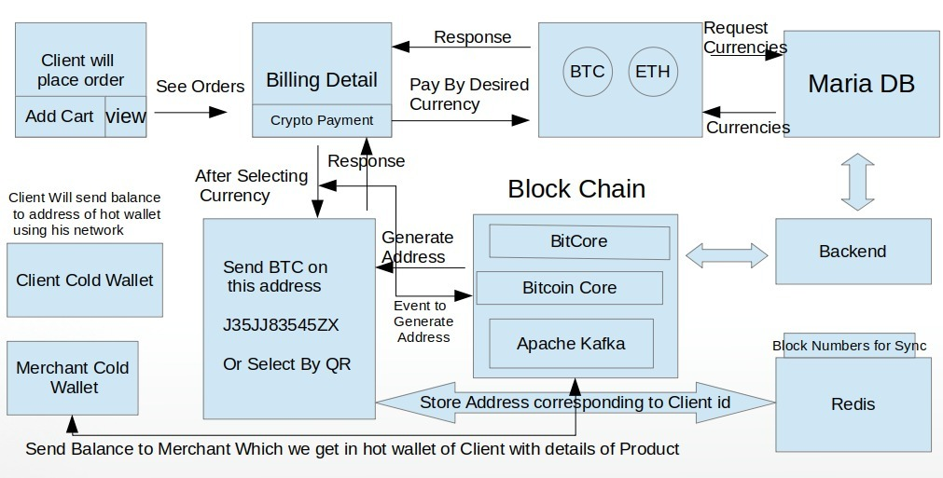

**Figure 4.1.5 System Architecture**

## Data Representation

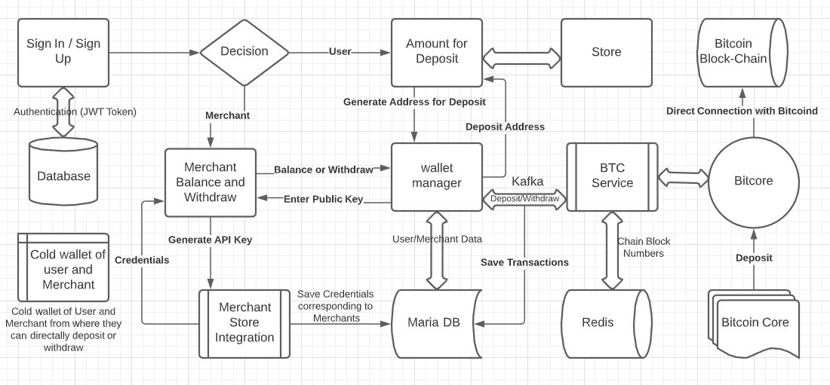

**Figure 4.2.5 Data Representation**

## Process Flow/Representation

Activity diagrams of proposed system are given below.

### Payment Processing

This activity will generate when buyer proceed his payments using our payment gateway on the merchant store.

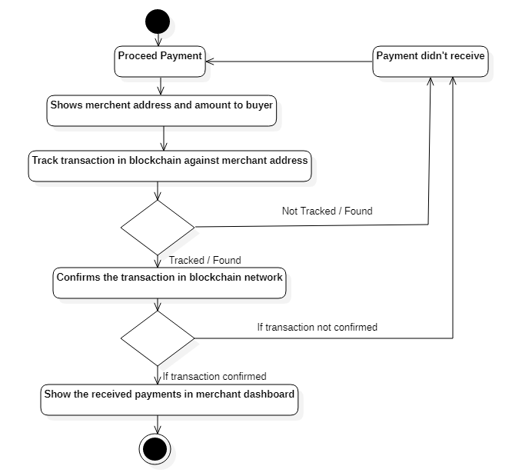

**Figure 4.3.5 Process Flow**

### Update Password

This activity will update the password of merchant account. Merchant will click on update password button and enters the old and new password. After that system will verify the old password and regex for new password. If there is no issue system will update the password successfully.



**Figure 4.3.5 Process Flow**

### Forget Password

This activity will update the password of merchant account. Merchant will click on forget password button and enters the email address. After that system will send the reset link to merchants account. On clicking that link merchant will be able to enter new password. System will verify the regex for new password. If there is no issue system will update the password successfully.



**Figure 4.3.5 Process Flow**

### Withdraw Amount

This activity shows how the withdrawal system works in out crypto payment gateway.

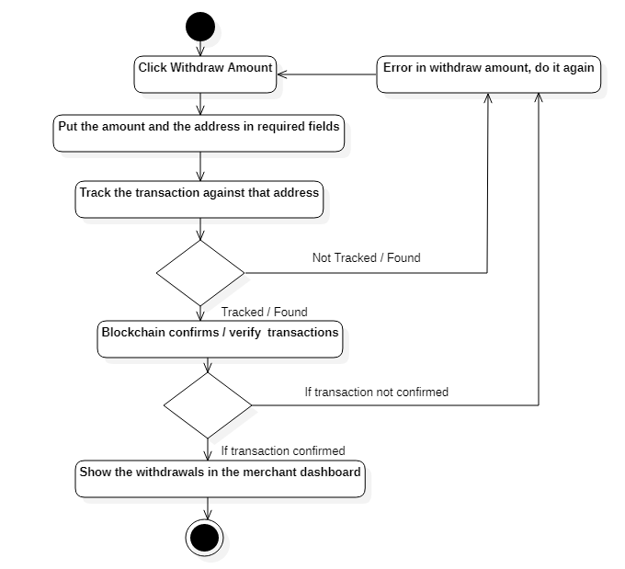

**Figure 4.3.5 Process Flow**

### Download Plugin

This activity will download the plugin for merchant’s to integrate it in their system and start receiving cryptocurrency.



**Figure 4.3.5 Process Flow**

### Request Api Key

This activity will provide the merchant’s API key to activate api integrated in their system so they can start receiving cryptocurrency.



**Figure 4.3.5 Process Flow**

## Design Model

Sequence diagram for Signup and Login.

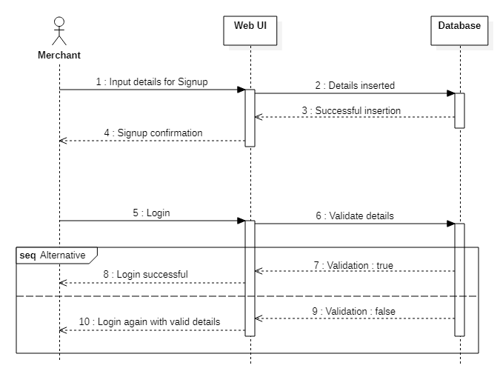

**Figure 4.4.1 Design Model**

Sequence diagram to proceed payment using our crypto payment gateway.

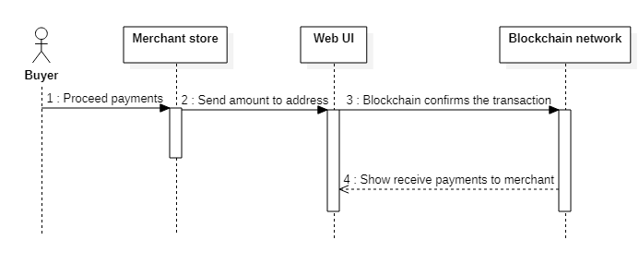

**Figure 4.4.2 Design Model**

Sequence diagram for merchant to withdraw his payments

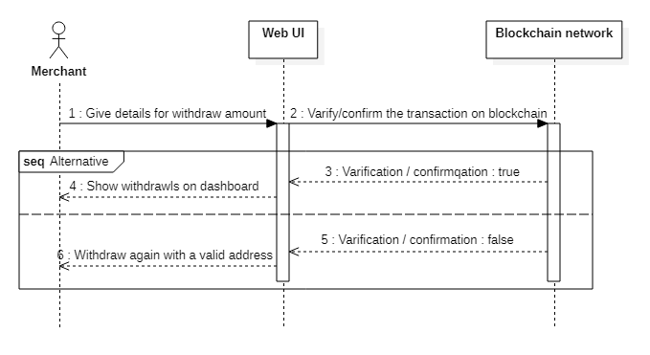

**Figure 4.4.3 Design Model**

# 

Chapter 5

Implementation

# Implementation

## Algorithm

### Elliptic Curve Digital Signature Algorithm or ECDSA

Elliptic Curve Digital Signature Algorithm or ECDSA is a cryptographic algorithm used by Bitcoin to ensure that funds can only be spent by their rightful owners. A few concepts related to ECDSA, these are follows:

**Private Key:** A secret number, known only to the person that generated it.

[**Public Key**](https://en.bitcoin.it/w/index.php?title=Public_key&action=edit&redlink=1)**:** A number that corresponds to a private key, but does not need to be kept secret. A public key can be calculated from a private key, but not vice versa.

**Signature:** A number that proves that a signing operation took place. A signature is mathematically generated from a hash of something to be signed, plus a private key.

### Cryptographic Hash Functions

Cryptographic hash function takes a block of input data and creates a smaller, unpredictable output. The hash function is designed so there’s no short cut to get the desired output, we just have to keep hashing blocks until we find one by brute force that works.

* + - 1. **SHA256 algorithm**

Different blockchains use different cryptography algorithms. The Bitcoin blockchain uses the SHA256 algorithm. The SHA-256 hash algorithm takes input blocks of 512 bits (64 bytes), combines the data cryptographically, and generates a 256-bit (32 byte) hash. To provide additional security, Bitcoin applies the SHA-256 function twice, a process known as double-SHA-256.

* + - 1. **ECDSA**

ECDSA is the cryptographic algorithm in the core of bitcoin addresses. It is an asymmetric signature algorithm, which means that you can sign messages with the PRIVATE key and verify the signature with the PUBLIC key.

## External APIs

### Bitcore

We use Bitcore Api that is an open source Node.js library used for a secure payment protocol and private key management. That Api is used to access private or public keys, perform peer-to-peer cryptcurrency transactions and manage the complete network in our payment gateway. We integrate our node.js backbend code with block chain network with the help of this BitcoreApi. We run server side on Node.js or client side in a web browser and interact with a bitcoin node.

### BitcoinD

We are using Bitcoind to implements the Bitcoin protocol, it provide us complete blockchain network, we have 3 networks of blockchain. The Testnet, Mainnet and Regtest. We are using Testnets for testing smart contracts, the Mainnet network for actual transactions with real bitcoin value and regtest for testing the network locally with fake transaction of bitcoin.

### Apache Kafka

We are also using Apache Kafka in our payment gateway which is an open-source, distributed streaming platform. We are using it for handling events; it is operating quickly, mostly due to its distributed nature. We are producing and consuming topics from one central place Instead of going to separate endpoints to get data.

## User Interface

### Screen Images:

**Landing Page:**

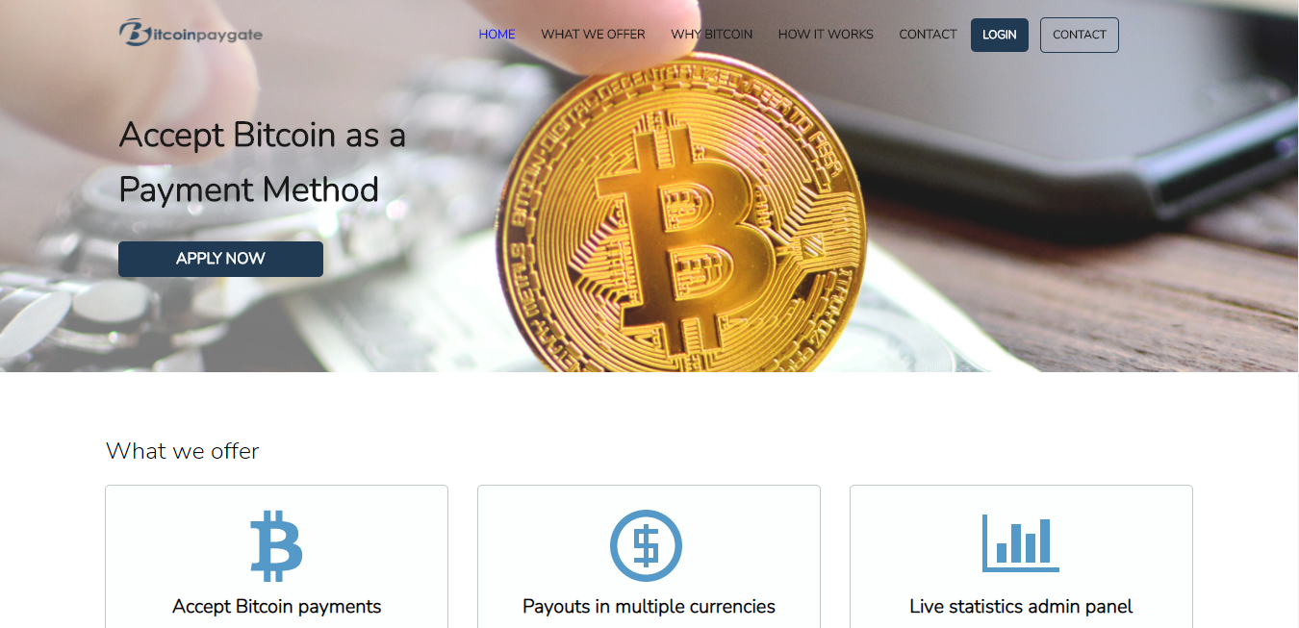

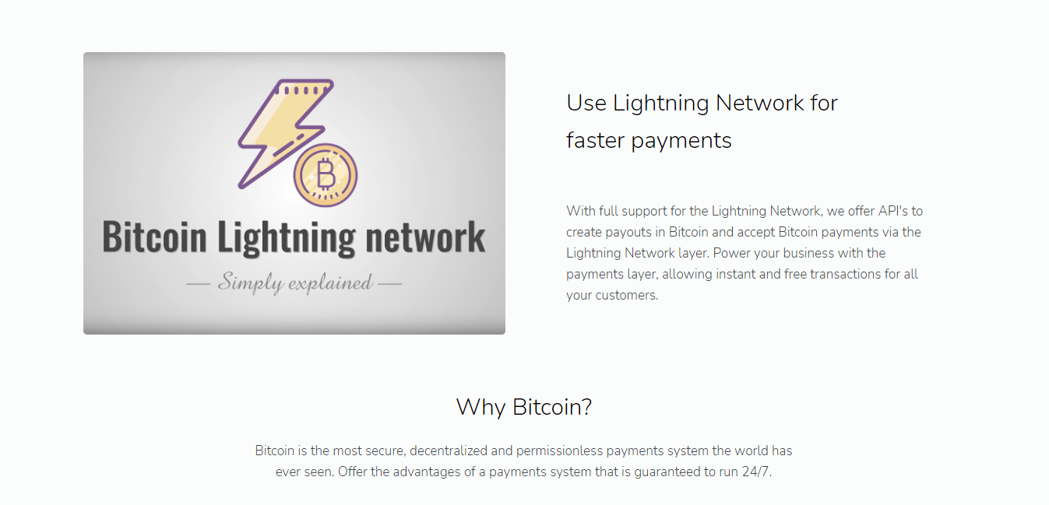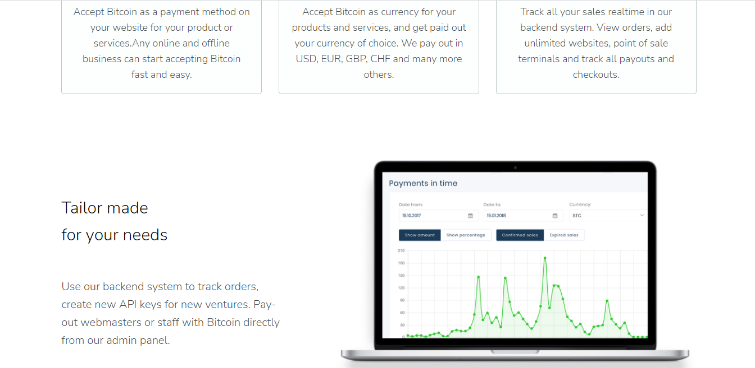

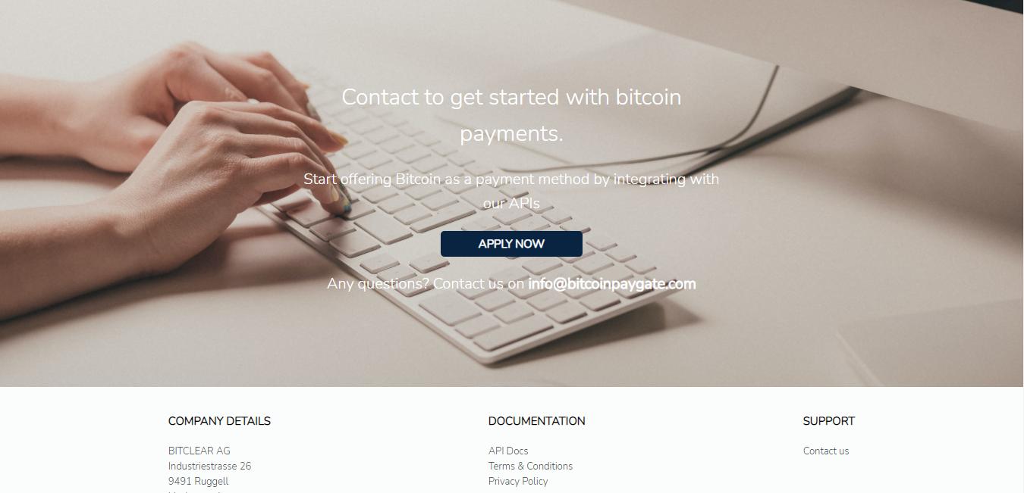

**Figure 5.3.1 Landing Page**

**SignUp Page**

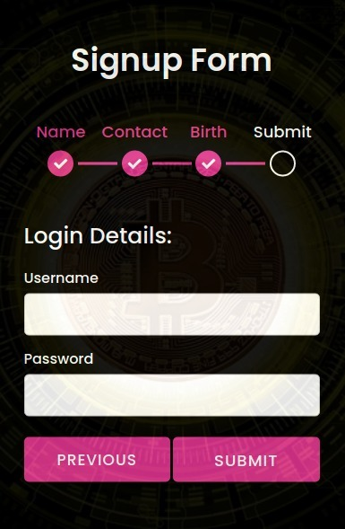

**Figure 5.3.2 Sign Up Page**

**LogIn Page**

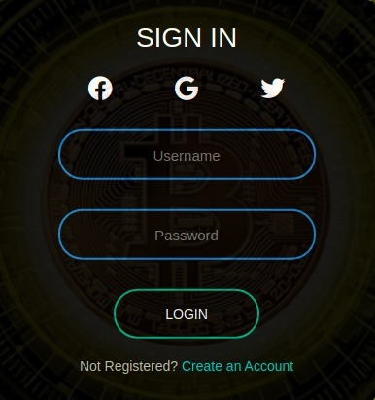

**Figure 5.3.3 Login Page**

# Forget Password Page

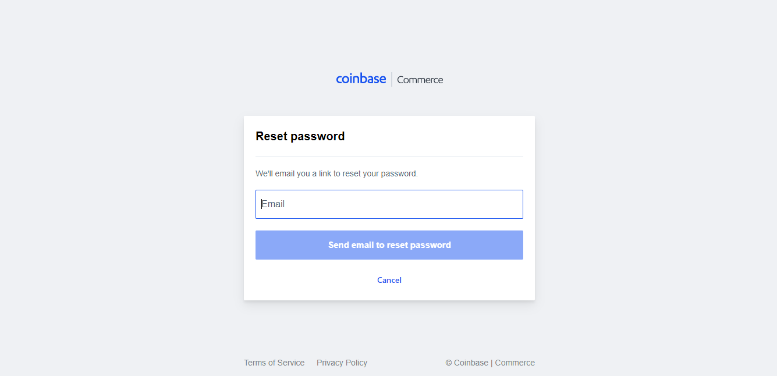

**Figure 5.3.4 Landing Page**

# Dashboard Page

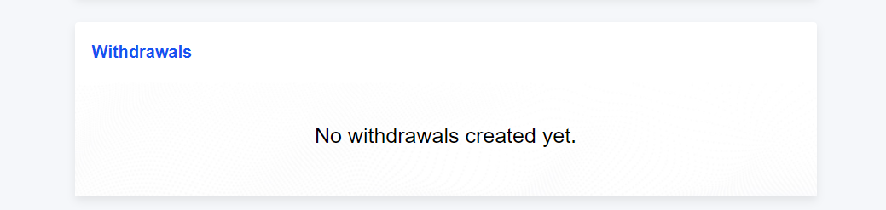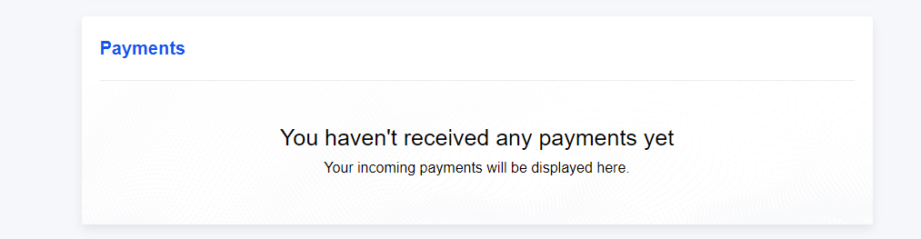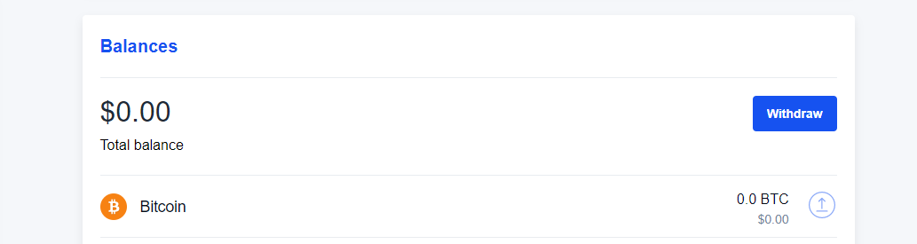

**Figure 5.3.5 Dashboard Page**

# Settings Page

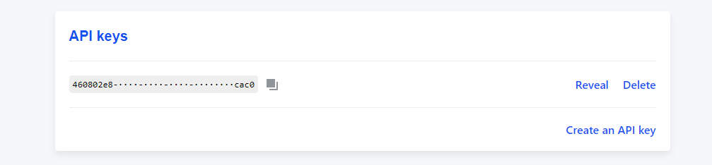

**Figure 5.3.6 Settings Page**

### Screen Objects and Actions:

**Login Button:**

It will take the user credentials and validate them. If they validate, user will be prompted to dashboard screen.

**Sign Up Button:**

If person is not a registered user on our website then sign up button is used to make an account.

**Forget Password Link:**

It will be used to recover password. For this an email link will be sent to user registered email to reset the password.

**Dashboard:**

On dashboard merchant can view his balance, withdraw his amount, and also view received payments.

**Settings:**

On settings merchant can generate the Api key, download the plugin and logout from system.

Chapter 6

Testing and Evaluation

# Testing and Evaluation

To make sure everything works as required, testing is crucial phase of development. To ensure that system is bug free we kept testing at each stage of development. From unit level code to component level we tested each integration phase.

## ManulaTesting

### System Testing

To ensure the system functionalities are working as required, we did system testing by using the system as a normal end user without going in technical aspects of system to observe external behavior of system. We tested our system against simple inputs that are basic requirements of system and analyzed the output without any debugging techniques to simple observe the overall performance and reliability of system. We test the design and behavior of the system and also the expectations of the customer by considering ourselves as a layman.

|  |  |  |  |
| --- | --- | --- | --- |
| **Phase to test** | **Test Description** | **Expected Results** | **Actual Results** |
| Signup | Merchant need to enter unique and valid email, valid password and confirms his password in order to sign in the system. | If merchant gives  Invalid emails or password, he got rejected otherwise he successfully registered in the Database. | Pass |
| Login | Merchant need to enter valid email and password to get access to dashboard. | If user exists, then he  will be logged into the system, otherwise he need to get registered with provided credentials. | Pass |
| Receive Amount | Buyer of merchant needs to copy the Btc address and the amount, and send that amount to the required address. | If buyer sends the amount to required address then merchant received it, otherwise not. | Pass |
| Withdraw Amount | Merchant withdraw his balance by providing the right address and amount. | If merchant don’t have any balance then he is unable to withdraw amount. | Pass |
| Generate Api Key | Merchant can download the woocommerce plugin and Generate the API Key to make a connection of his account with store. | If merchant first login the system and then generate API key then he get the API Key otherwise not. | Pass |

**Table 6.1.1 System Testing**

### Unit Testing

We perform unit testing to validate that each unit or component of the software code performs as expected, we tested the system with debugging techniques with the help of our development tools (jasmine) for both frontend and backend written in JavaScript. We used breakpoints after and before every method execution to see the system behavior internally. It helped us to remove minor syntax errors and basic functionality of the module. We tested interface units and backend units separately to observe the desired results before integration.

### Functional Testing

We perform functional testing to test each function of the software application, by providing appropriate input, verifying the output against the Functional requirements. We checks User Interface, APIs, Database, Security, Client/Server communication and other functionality of the application under test conditions.

|  |  |  |  |
| --- | --- | --- | --- |
| **Phase to test** | **Test Description** | **Expected Results** | **Actual Results** |
| Database insertion  In signup. | Merchant record  Inserted in database  after merchant  Signup with accurate details. | Record successfully inserted in database with unique id and email. | Pass |
| Forget password | Merchant click on Forget password, and then get a link on his email to reset password. | After merchant get the link he add new password and confirms the password, the new record successfully inserted in database | Pass |
| Generate address for  Buyer/Client. | When buyer proceed payment on store of merchant he get the amount and the address to where he sends the amount | If buyer doesn’t add any products to his cart and then proceed payments he will not get the address | Pass |
| Generate address for  Merchant to withdraw  Payments. | Merchant click on withdraw payments, and then put the address and the amount, then block chain network verify/confirms that transaction. | If merchant put right address only then he will be able to withdraw amount otherwise not. | Pass |

**Table 6.1.2 Functional Testing**

### Integration Testing

We integrated the system modules and tested the functionalities after integration. All the major modules are tested side by side by actual inputs to see the results. We solved various issues of integration by debugging techniques. This functional testing allows us to test out integration of frontend with backend and blockchain specific issues.

We also successfully tested the integration of node.js with database of our system. We also tested the integration of apache/kafka from frontend. These successful integrations allow us to freely move our data around three platforms without any exceptions.

|  |  |  |  |
| --- | --- | --- | --- |
| **Phase to test** | **Test Description** | **Expected Results** | **Actual Results** |
| Frontend integration of  User registration with  Backend. | When a user input details, we successfully integrated that front end with the endpoint on backend, and inserted the details from frontend to database on backend. | This needs to done if user input valid details otherwise he Got error. | Pass |
| Change settings e.g change  Password. | Merchant can change his password and get access to that end point which change the password and then insert that record in the database | To change password merchant need to enter the old and the new password, that change the password in database with shows successful integration. | Pass |
| Generate address for buyer. | We are listening to the endpoint that is generated by buyer, when he proceeds payments after adding products to his cart. | That integration works successfully by providing the address and the amount to the buyer. | Pass |
| Received payments to merchant | When buyer sends the amount to the right address, merchant see the received payments in his dashboard. | That integration needs to work if buyer put the right address otherwise not. | Pass |
| Withdraw amount by merchant. | Merchant can view the withdrawals he makes after the amount successfully sends to the wallet. | If the amount exist in his dashboard and the merchant put the right address, and then the transaction successfully happens in the blockchain network then merchant can view the withdrawals in his dashboard otherwise not. | Pass |

**Table 6.1.3 Integration Testing**

## Automated Testing

We perform automated testing using special automated testing software tools to execute a test case suite. We use TestNG framework that is capable of making Selenium tests easier to understand. The main advantages of TestNG are the annotations are easier to use and understand, test cases can be grouped more easily and the TestNG allows us to create parallel tests.

We also test our restApi’s with JMeter to execute performance testing, load testing and functional testing of web applications, to check how many users use our system at a time without any load on server.

|  |  |  |  |
| --- | --- | --- | --- |
| **Phase to test** | **Test Description** | **Expected Results** | **Actual Results** |
| Register User | We test the SignUp and login by giving the details in the input fields, then check if details are valid or not and the validations on input fields are working or not. | If user input wrong details e.g (email and password are not valid), then he can’t get access to dashboard otherwise he can. | Pass |
| Withdraw amount. | After putting the address and the amount in the input fields,  The blockchian network verifies and confirms the transaction to that address. | If merchant put the wrong address or if he don’t have enough balance then he can’t withdraw his amount otherwise he can. | Pass |
| Buyer makes payment. | When buyer makes a payment, He got the amount and the address to where he sends the amount. | Buyer can’t make the payment if he sends the amount to wrong address otherwise he can. | Pass |
| Merchant received payments | When a client sends the amount at the given address then merchant view the payments he received on his dashboard | Merchant can receive the payments whenever a customer buys something from his store. | Pass |

**Table 6.1.4 Automated Testing**

## Tools used:

We used Selenium as an automated software testing tool for testing our crypto payment gateway. It automates browsers, enabling users to sail through various browser-specific testing purposes.

We also use postman for testing out endpoints and check the successful integration of frontend with backend.

Chapter 7

Conclusion and Future Work

# Conclusion and Future Work

## Conclusion

If you have followed every chapter, not have only you deepen your understanding of our crypto payment gateway but you have also learnt its development and designing process.

We gave our best to explain every aspect of each individual part, so it will not cause confusion.

Each chapter explains everything about the crypto payment gateway, and each chapter briefly describes what and how we did it.

## Future Work

As the use of bitcoin and other virtual currencies is increasing day by day, we will also enhance our crypto payment gateway by providing support for other virtual currencies like Ethereum, Litecoin, Bitcoin Cash and Dai etc.

We will also provide additional functionalities like donating amount in crypto currencies and we will also add the functionality of integration that payment gateway with shopify or any other website.

Chapter 8

References

**8. References**

[1] Collins Mukabi & Nguyen Long Vu, (May 2019), literature review. Retrieved from:

[www.diva-portal.org](http://www.diva-portal.org/)

http://www.diva-portal.org/smash/get/diva2:1372518/FULLTEXT01.pdfx

[2] [Cassiopeia Services](https://cassiopeiaservicesltd.medium.com/?source=post_page-----12bebb7c3849--------------------------------), (Feb 28, 2019). Challenges and issues in cryptocurrency trading.

Retrieved from: https://cassiopeiaservicesltd.medium.com/challenges-and-issues-in-cryptocurrency-trading-beyond-the-controversies-12bebb7c3.

[3] [Raluca Diaconu](https://blog.2checkout.com/author/raluca-diaconu/), (April 4th, 2019). Online payments processing challenges and How to overcome them. Retrieved from: https://blog.2checkout.com/online-payment-processing-challenges-overcome/

[4] [Stefan Cenusa](https://blog.2checkout.com/author/stefan-cenusa/), (July 9th, 2020). Advantages and challenges of accepting online payments.

Retrieved from: https://blog.2checkout.com/advantages-and-challenges-of-accepting-payments-online/